# Podplay.me: Usability Test Report

Date of Report: April, 2015

Date of Test: April 14th, 2015

Location of Test: GUI Classroom

Prepared for: Professor Heines

Email: [jesse_heines@uml.edu](mailto:jesse_heines@uml.edu)

Prepared by: David Zimmelman and Ian McGaunn

Email: [dzimmelman@gmail.com](mailto:dzimmelman@gmail.com) and [ianmcgaunn@gmail.com](mailto:ianmcgaunn@gmail.com)

Table of Contents

Podplay.me: Usability Test Report 1

Summary 1

Methodology 2

Who we tested 2

Results 2

Analysis and Discussion 5

What we fixed 5

What we can’t fix 5

The usability test experience 5

## Summary

This study was performed in order to get user feedback about the design and functionality of an early version of the Podplay.me website. The test subjects were given a short list of tasks designed to maximize the level of interaction they had with core site features and were encouraged to give feedback throughout their entire experience with the site. Feedback regarding the navigation features on the site was especially encouraged as it had the largest impact on the user experience.

The list of tasks test subjects were asked to complete are as follows:

* Browse for and select a podcast on the main page
* Search for a podcast
* Play a podcast

The list of tasks is intentionally limited with the hope that users will explore related features of the site independently. To further emphasize the level of usability we were trying to achieve with Podplay.me’s interface, the subjects were not given any further instruction about how to complete these tasks. In creating the product, familiar design paradigms from other platforms were used to try to make each of its functions intuitively obvious. These design goals for the product greatly influenced the design of the usability test.

## Methodology

### Who we tested

The test subjects were primarily Computer Science students from the GUI Class. What was important about the group of students is that there was a wide range in their experiences with podcasts and podcast applications, which provided some level of diversity in our test subjects. We had six individuals test our application and provide feedback

### Results

While detailed commentary and results from each participant is available in the attached documentation, this report will focus on analyzing the more general conclusions that can be drawn from the test as a whole

Due to the relatively simple nature of the application, none of the participants experienced significant difficulty performing the tasks required of them. Since our interface mirrors other media streaming products like YouTube and Netflix, the users had a very good sense about how to operate the product.

#### What users liked

* **Back button** – users consistently said they liked the back button at the top of the page and were able to use it without any intervention from the test administrators.
* **Quick search** – the instant visual feedback from the quick search feature on the website helped make it easy for participants to identify its function and learn how to use it.
* **Tile-based browsing view** – users enjoyed that the main view of the application made it easy for them to identify groupings according to genre of podcasts and to discover certain podcasts without having to issue a search.

Although the users did provide a lot of positive feedback about the application in its current state, they did have a number of useful criticisms of the interface.

#### What users said needed improvement

* **The distinction between quick search and regular search** – users enjoyed the way the quick search functioned, but indicated that there was no clear visual indicator of when they were doing a ‘quick’ search (which gathers results from Podplay.me’s own cache) and a ‘full’ search which asks the iTunes API for more detailed results. This distinction can be improved by adding a visual cue, such as a button that says ‘view all’ which indicates that pressing that button will have a different result than simply typing in the search box.
* **Include more information about podcasts in the main view** – Many users stated that although it was easy to find and play podcasts with the current UI structure of Podplay, it would be even better if information about podcasts could be displayed inline as part of the main view. This would make the user more comfortable by reducing the number of graphical context switches necessary to use the application. Both Netflix and iTunes have solutions for this, the solution the latter uses is illustrated in Figures 1 and 2

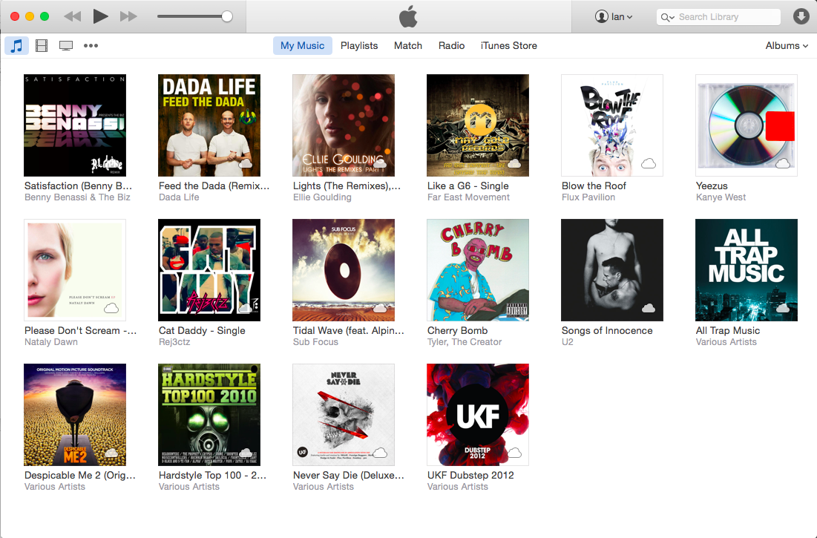

Figure 1: Collapsed inline album info in iTunes

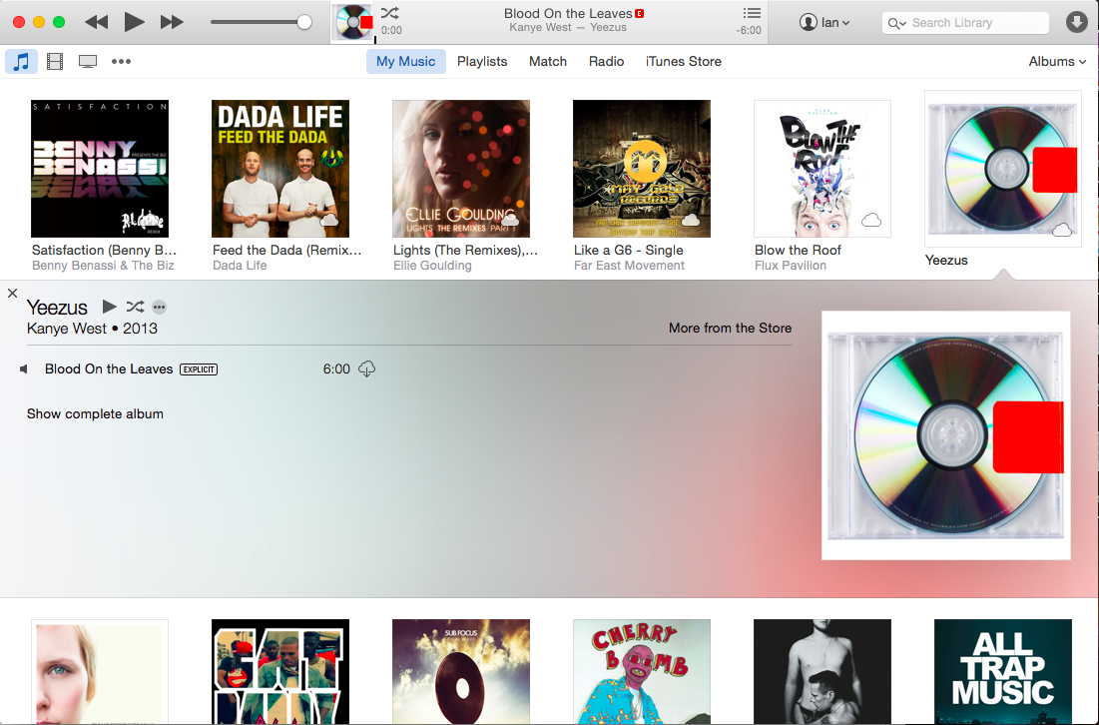

Figure 2: Expanded inline album info in iTunes

## Analysis and Discussion

### What we fixed

The results clearly indicate that changes should be made to help distinguish the differences between the ‘quick’ and ‘full’ searches and that we should also reduce the number of graphical context switches the users need to make to effectively use the application.

To address the concerns about the distinction between the ‘quick’ and ‘full’ searches, we have added a button labeled ‘view all’ next to the search bar to make it more obvious that there is a difference in functionality and to describe in simple terms what the difference is. Also, while a user types a query it will indicate in the results box ‘quick results’, making the result type being returned to the user more explicit.

We have also added a fix that intends to mitigate some of problems with unnecessary graphical context switches in our application. Before, when a user wanted to listen to a podcast they would have to click on the podcast’s tile and they would be sent to another page specific to that podcast. The problem with this is that it makes it more difficult to quickly look at a podcast, decide you don’t want to listen to it and search for another one. In newer builds of Podplay, a strategy very similar to the one that iTunes uses (depicted in figures 1 and 2) has been implemented, making it unnecessary for users to ever leave the main page.

### What we can’t fix

Since the user feedback about our application was so specific, it was relatively straightforward (if not a lot of work) to respond to their suggestions and improve our application significantly. As far as this usability test is concerned, there weren’t any major problems users had which we were unable to resolve.

### The usability test experience

This particular usability test was very useful. Although we had some indication about what parts of our product might be difficult to use, getting real qualitative assessments from users that weren’t involved with the development of the product was valuable. In addition to it illuminating some of the negative aspects of our software, we learned that certain parts that we did not anticipate would be particularly popular (our back button, for example) were actually widely appreciated. Having real user feedback also helps set priorities for fixing various negative aspects of the software by giving us a better indication of how much they degrade the user experience.

After integrating feedback from the usability test, we think that our user interface has improved significantly. We have developed a novel interface for a podcasting application that has evolved very well as a result of user feedback.